STARAGILE GIT ASSIGNMENT 1

Certainly! Here are the steps to complete the assignment:

1. **Install Git on AWS Ubuntu:**
   * Connect to your AWS Ubuntu instance.
   * Install Git

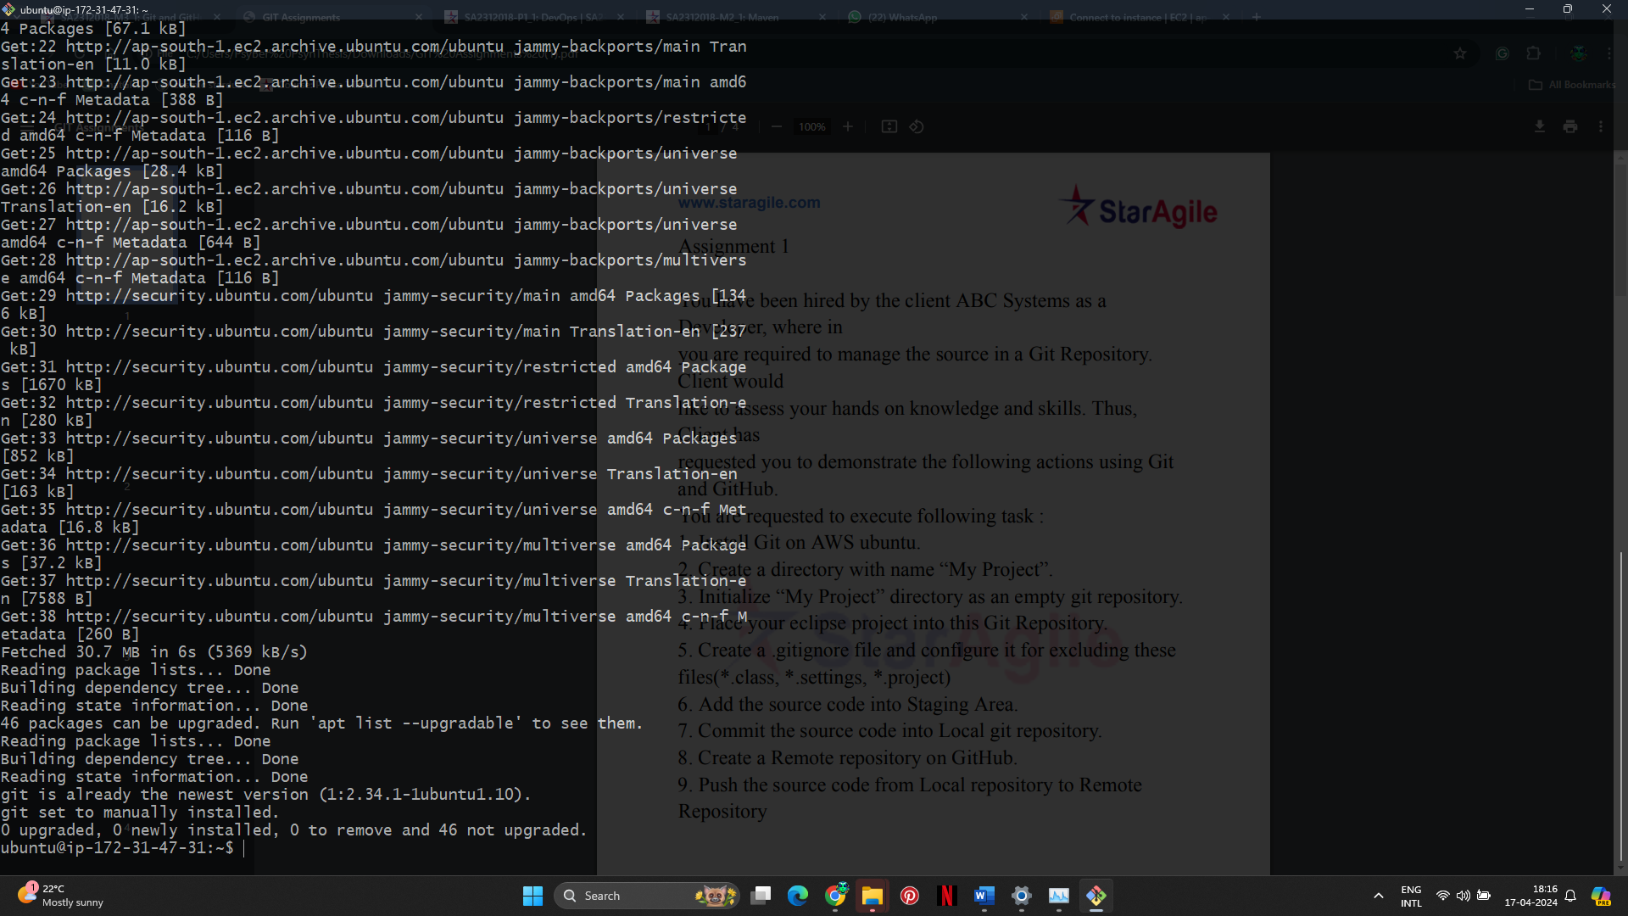

1. **Create a directory with the name "My Project" and navigate into it:**

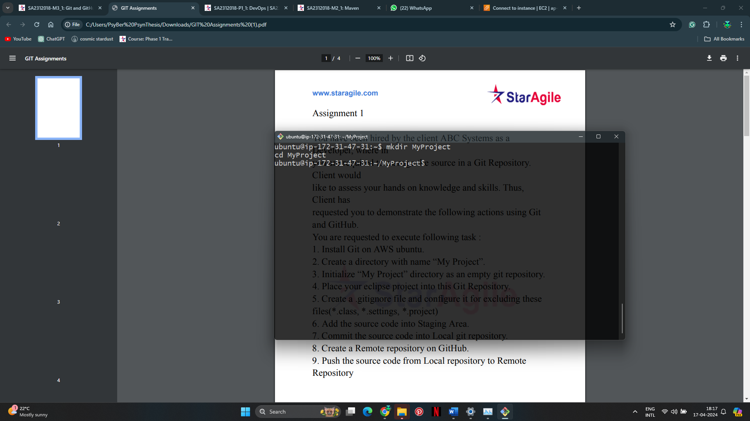

1. **Initialize "My Project" directory as an empty Git repository:**

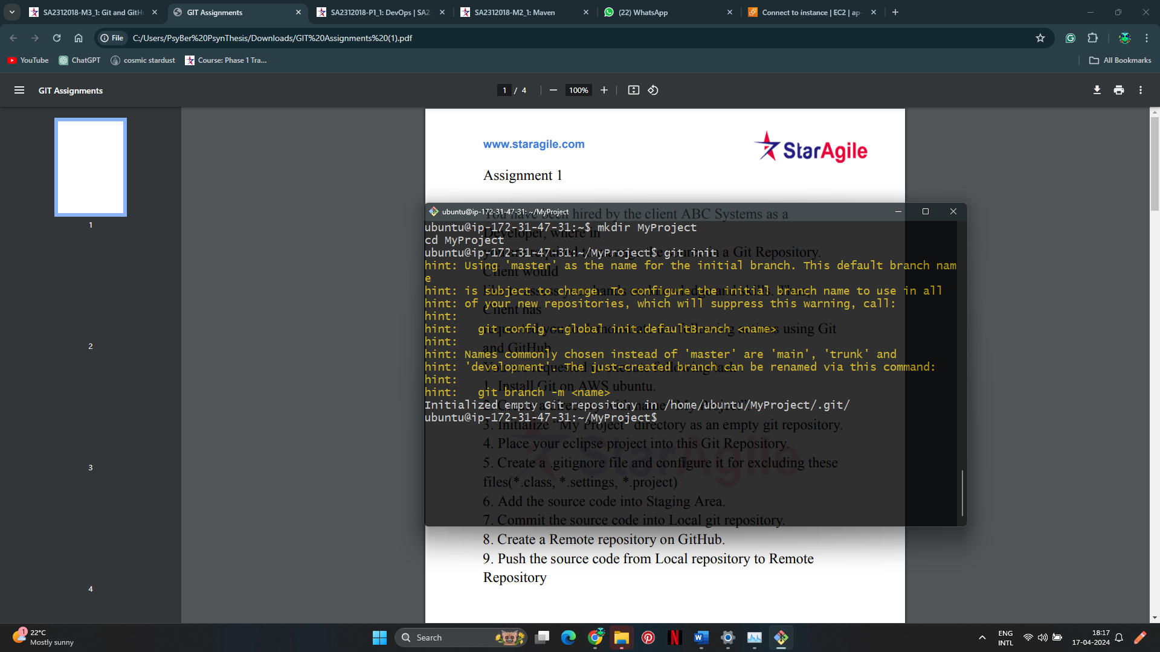

1. **Place your Eclipse project into this Git repository:**
   * Copy your Eclipse project files into the "My Project" directory.

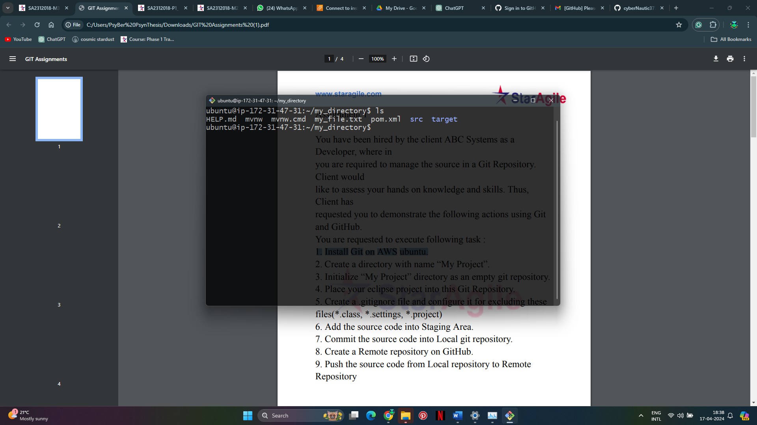

1. **Create a .gitignore file and configure it to exclude specific files:**
   * Edit the **.gitignore** file and add the following lines:

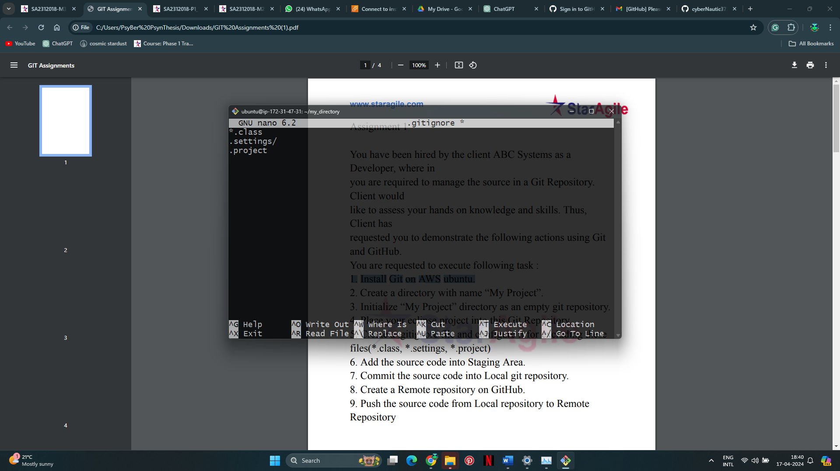

1. **Add the source code into the staging area:**
   * add all files to the staging area:

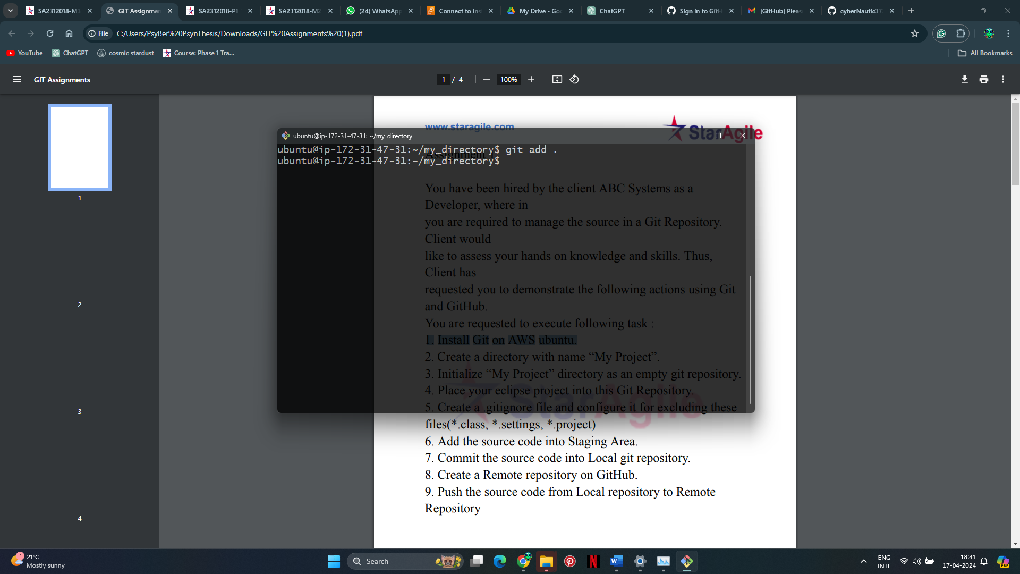

1. **Commit the source code into the local Git repository:**
   * Commit the changes

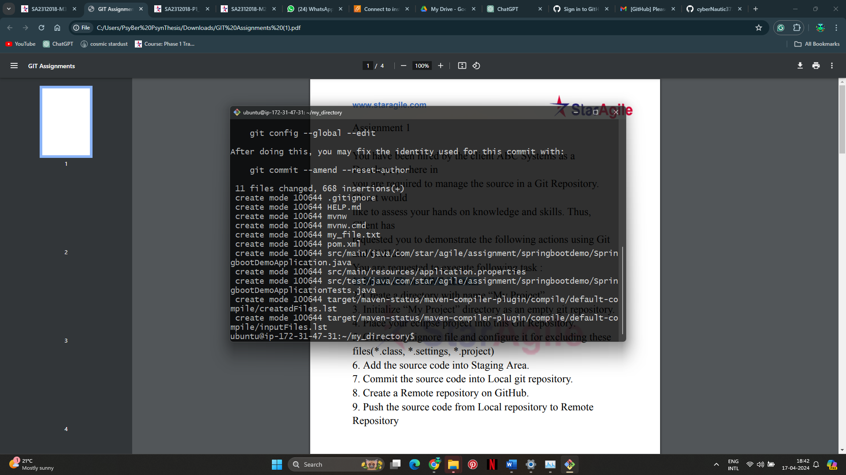

1. **Create a remote repository on GitHub:**

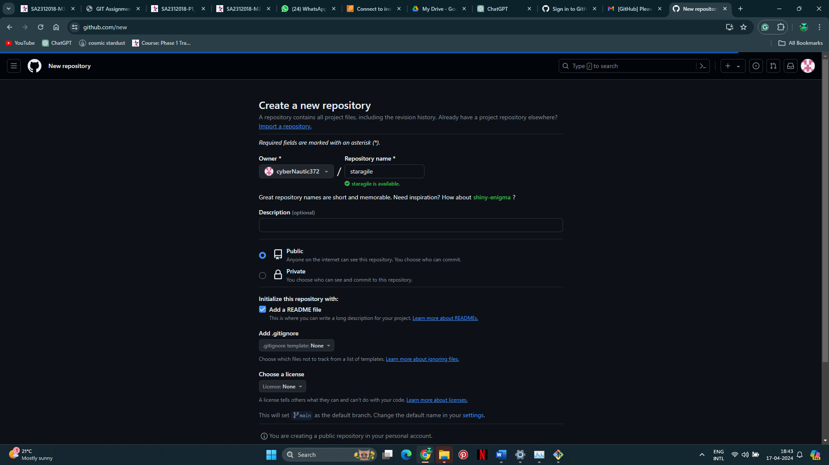

1. **Push the source code from the local repository to the remote repository:**
   * Copy the URL of the remote repository you just created on GitHub.

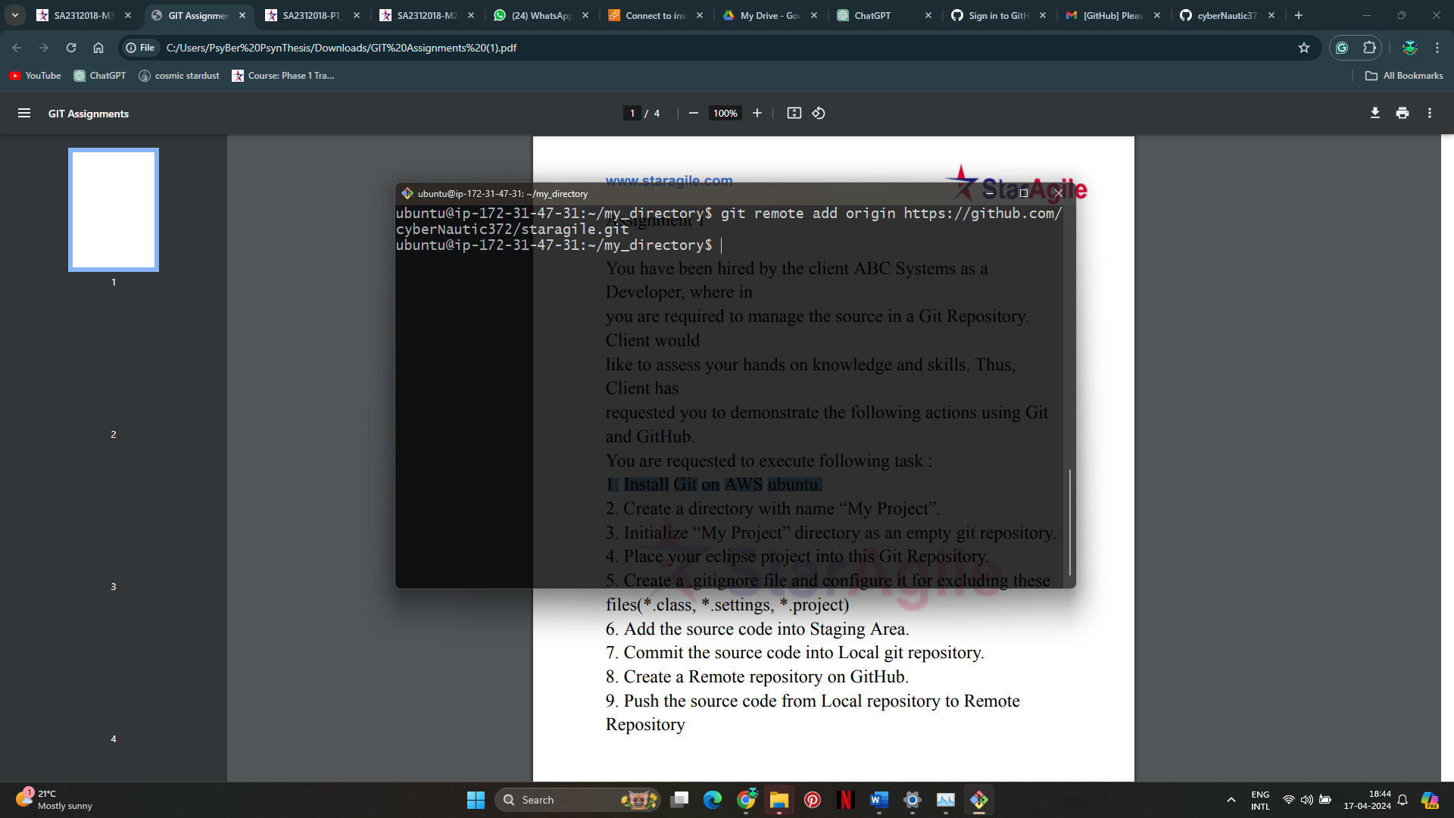

* + Push the local repository to the remote repository using the following command:

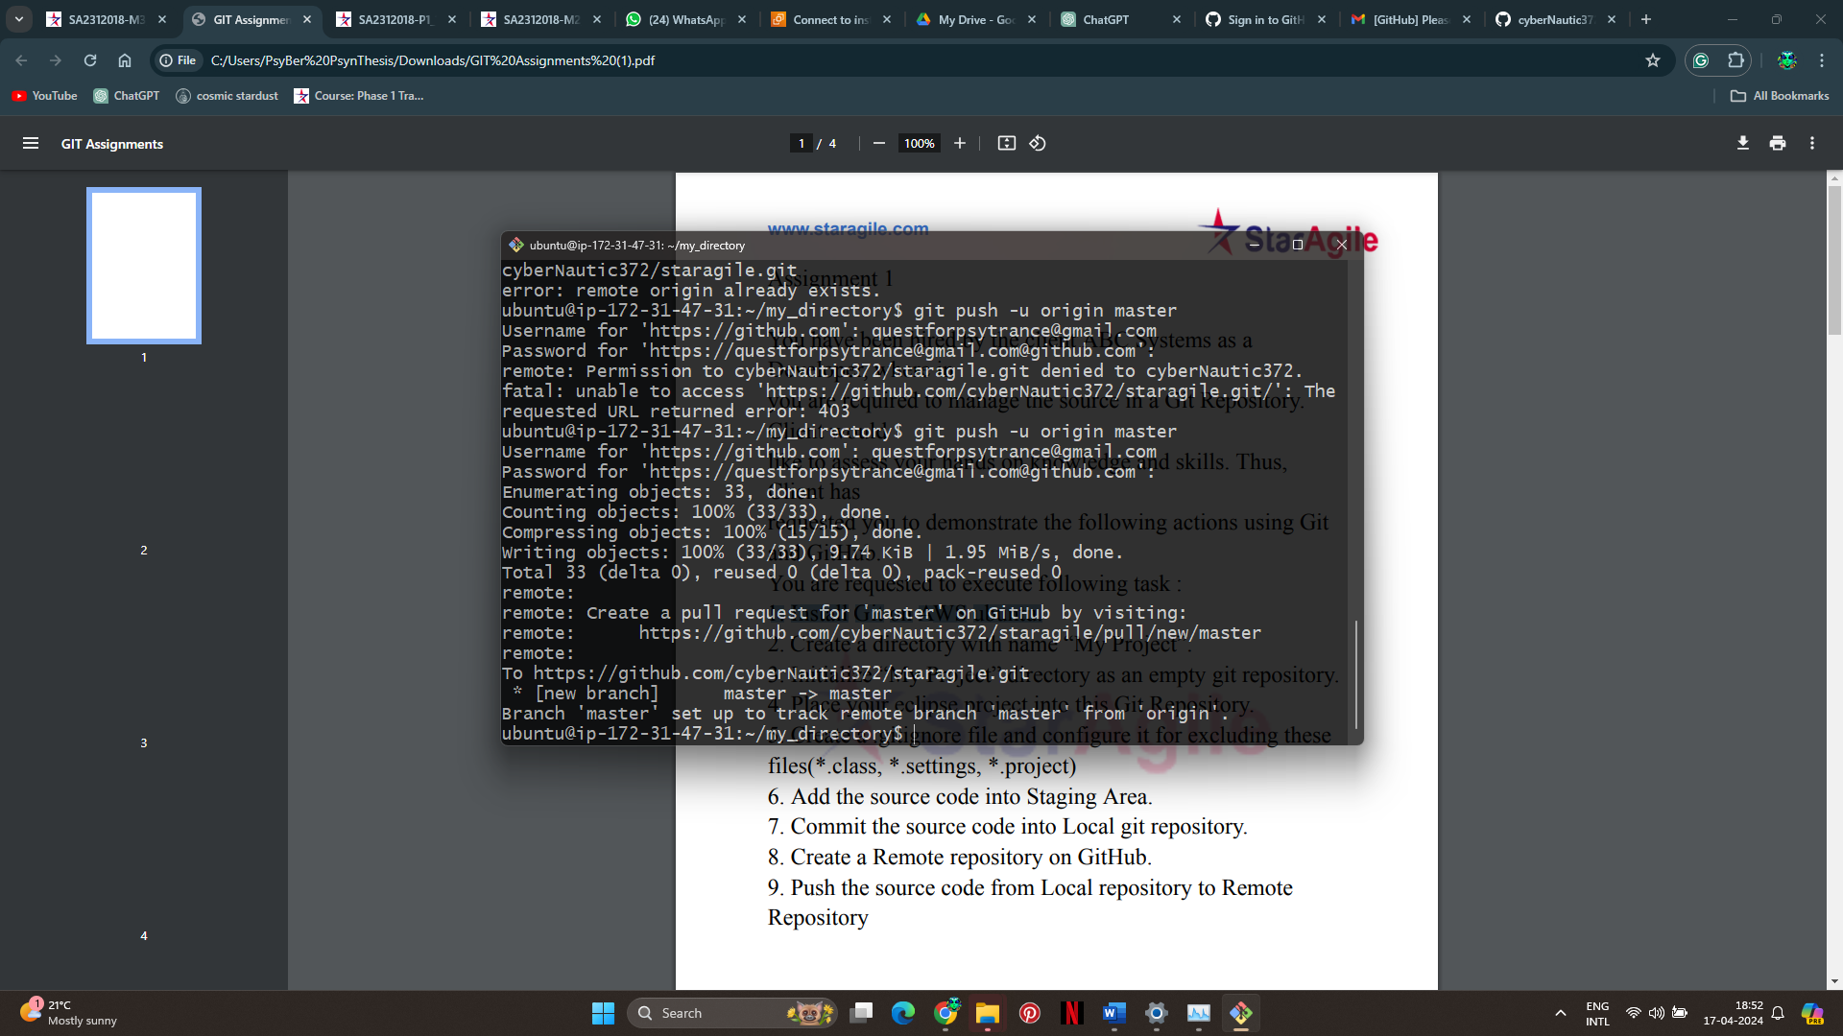

Pushed objects appeared in the repository correctly

